MATH 4371 MIDTERM (Spring 2008)

Name: SID:

The following is an assortment of True/False (the appropriate one to be circled) questions, fill in the blank questions, and computational questions. Use either machine you wish, or neither machine as you see fit. Read each question very carefully, and for those that require written response, be as neat and to the point as possible.

1. Assume m, n, and r are positive integers.
a. What does it mean to say that "r is the greatest common divisor of m and n" ?
r is the biggest integer that divides evenly into both m and n.
b. What does it mean to say that "r = m mod n" ?
r is the remainder when m is divided by n.
c. Compute the following integers:
gcd(8,12) = 4
gcd(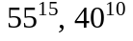) = 9765625
9 mod 5 =4
lcm(508,450) =114300
10 ! mod 5 =0
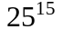 mod 2 =1
d. Explain why and odd integer times and odd integer must be an odd integer.

(2n+1)(2m+1)=4nm+2n+2m+1 is odd
Or if there is no 2 in the prime decomposition of neither m nor n, then there can be no 2 in the prime decomposition of mn.
2. State the FUNDAMENTAL THEOREM OF ARITHMETIC.
Demonstrate this theorem for the integer 50!.
Every integer bigger than 1 can be written in a unique way (up to order of terms) as the product of powers of primes.
50!=

3. Convert the following numbers in Sci-Notation to the equivalent actual number.
1.9123 E5 =191230
1.9123 E-5 =0.000019123
4. What are the integer fractions represented by the following decimal numbers.
2.2333 =
2.233 =
TRUE
5. Not all real numbers have an equivalent integer fraction representation.

6. There are rational numbers which the calculator can not convert to integer fraction form.
TRUE

7. What does the BINOMIAL THEOREM tell us?
In the expansion of (a+b)^n the coefficient of the term a^(n-k)b^k is nCk.
Use MAPLE to demonstrate the BINOMIAL THEOREM.
> expand((a+b)^5);
seq(binomial(5,k),k=0..5);
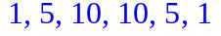

What is the coefficient of 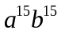 in the expansion of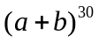?


TRUE
8. MAPLE can find the exact roots of all cubic polynomials.

9. The calculator can find the exact roots of all quadratic polynomials.
FALSE

10. The calculator can factor any polynomial into a product of powers of first
degree polynomials.
FALSE

11. Find all the roots of each of the following polynomials:
a. 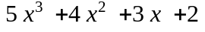
> fsolve(5*x^3+4*x^2+3*x+2,x,complex);
b. 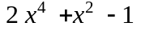
> solve(2*x^4+x^2-1);
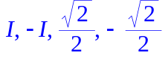

What do the roots of a polynomial have to do with its graph?
The real roots are the values of x where the graph crosses the x-axis.

12. Factor each of the following polynomials into a product of 1st order terms:
=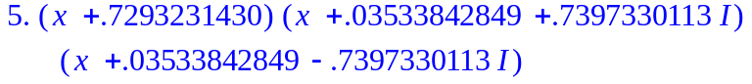 can be obtained by using the roots from #11

=> factor(2*x^4+x^2-1);
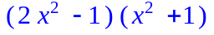
is not completely factored into linear terms
> factor(2*x^4+x^2-1,complex);
can be obtained using the roots from #11

What do the factors of a polynomial have to do with its roots?
There is one linear factor for each root. If r is a root then (x-r) is a factor and vice versa.

13. Insert the graph of the following function: 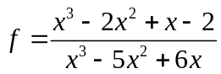 .
I used > plot(f,x=-10..10,y=-2..15,discont=true);
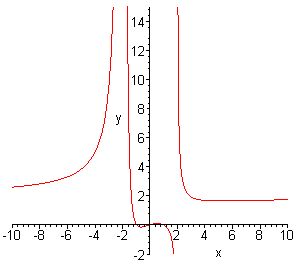

What are the vertical asymptotes of f?
x=-2, +2 The zeros of denom(f). Use factor(denom(f));

What is the horizontal asymptote of f ?
y=2 (I accepted any answer from 1 to 2. Look at the graph.

14. Find the x-intercepts of the graphs of each of the following functions:

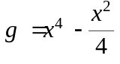
x=0 , ½, - ½ Just use solve(g=0);

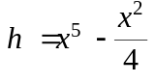
x= 0,0, .62996 Use fsolve(h=0);

15. For any polynomial p(x) you can always find a number M so that the graph of p(x)+M never crosses the x-axis.
FALSE

16. For any even degree polynomial p(x) you can always find a number M so that the polynomial p(x)+M has no real roots.
TRUE

17. For any odd degree polynomial p(x) you can always find a number M so that the polynomial p(x)+M has exactly one real root.
TRUE

18. Some graphs of functions contain a vertical line.
FALSE

19. Suppose the following is the graph of some unknown function h(x).

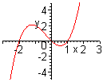
-2, 0, 1
What are the solutions to the equation h(x)=0?

How does the graph of h(x)+1 compare with the graph of h(x)?
How does the graph of h(x+1) compare with the graph of h(x)?
The graph of h(x)+1 is the same as the graph of h(x) raised 1 unit up.
The graph of h(x+1) is the same as the graph of h(x) moved one unit to the left.
20. Insert a picture which shows the effect of changing the parameter k on the graphs of y= x³-4x+k.

> plot({seq(x^3-4*x+k,k=-2..2)},x=-4..4,y=-10..10);

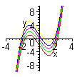
21. (Bonus) Insert a picture of the graph of a function y=g(x) satisfying the following properties: the zeros of g(x) are at x=-1 and x=0, g has a vertical asymptote at x=2, and g has horizontal asymptote y=1.

I used 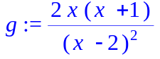
> plot(g,x=-10..10,y=-1..10);

